Create and Configure an IAM User & Group with AWS Managed Permissions
Objective :
To create an IAM group with predefined (AWS-managed) permissions, add a new IAM user to the group, and verify permissions by logging in with the IAM user.
Step 1: Login to AWS Console
- Sign in to your AWS Management Console using your root account.
Step 2: Create an IAM Group
- Navigate to IAM → User groups → Create group.
- Enter Group name: Developers
- Under Attach permissions policies, select:
  - AmazonS3FullAccess
  - AmazonEC2ReadOnlyAccess
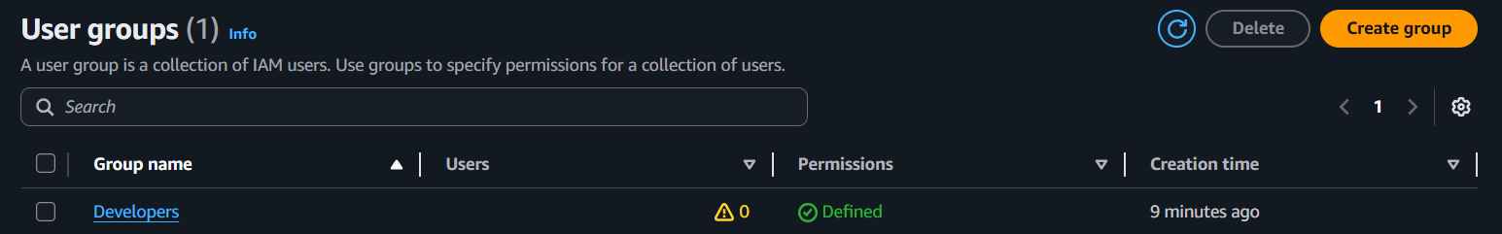
- Click Create group.

Step 3: Create an IAM User
- Navigate to IAM → Users → Create user.
- Enter the User name: dev-user-01
- Enable Provide user access to the AWS Management Console
- Go for Autogenerated password
- Click Next.
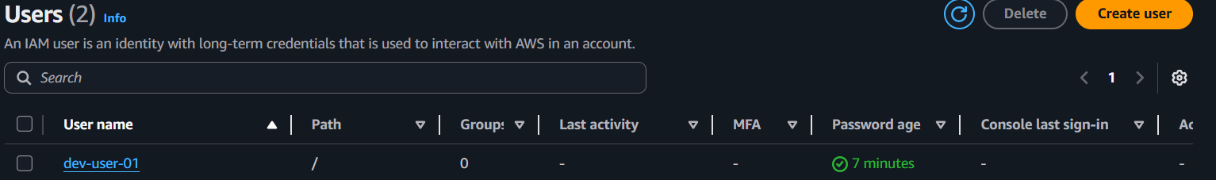
- Click Create User and download .csv file(it has users login details).
Step 4: Add the User to the Group
- Go to IAM → Users → Click user dev-user-01
- On the permissions page → Add permission → Choose Add user to group.
- Select the Developers group you created.
- Click Create user.
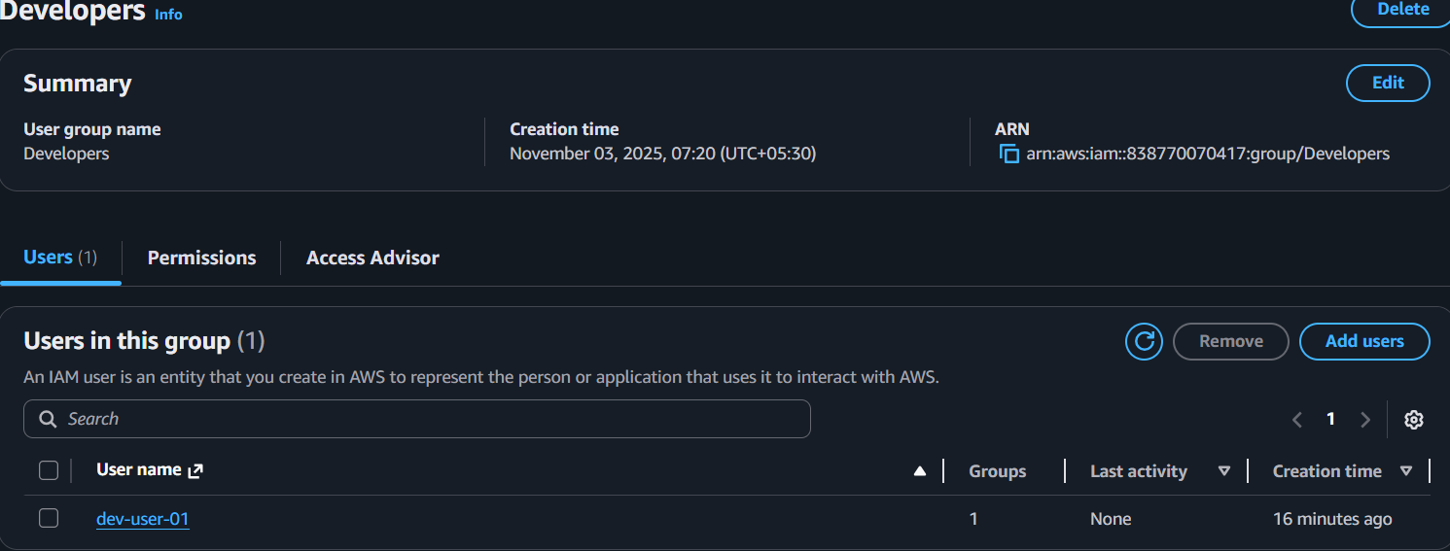
Step 5: Verify Access
- Sign out from root account and login to IAM user account using:
  - Account ID
  - IAM username : dev-user-01
  - Password : Use password which is in the .csv file and the set our own password
- Open S3:
  - Navigate to Amazon S3 → S3 → Create Bucket.
  - You should have Full Access (can create buckets, upload files, etc.)
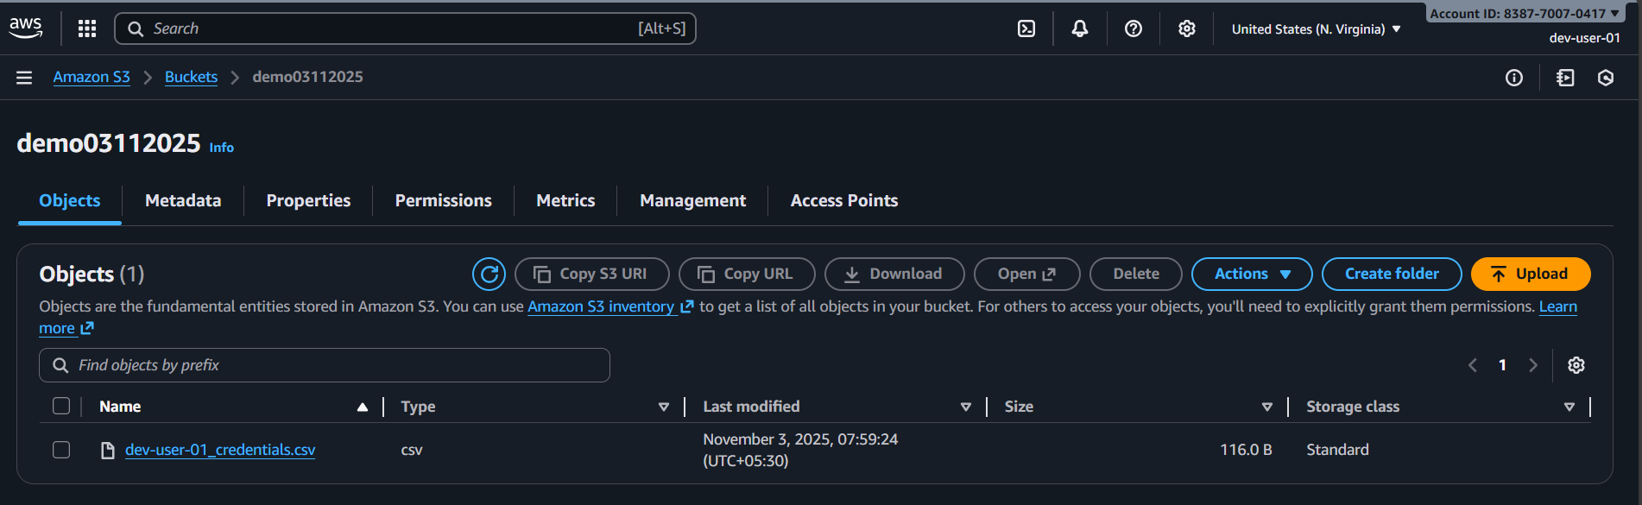
  - Create bucket uploaded a file.
- Open EC2:
  - Navigate to EC2
  - You should only have Read-Only Access (can’t able to create or delete instance)
